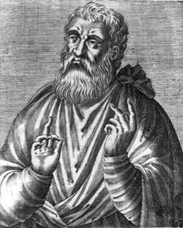
JUSTIN MARTYR

Justin Martyr, laid out one of the earliest descriptions of the Mass in his First Apology, written between 153 and 155 A.D. It’s great, because it offers a simplified version of Catholic theology intended for those who had no idea what a “bishop” was, or even what “Amen” meant.
Having ended the prayers, we salute one another with a kiss. There is then brought to the president of the brethren bread and a cup of wine mixed with water; and he taking them, gives praise and glory to the Father of the universe, through the name of the Son and of the Holy Ghost, and offers thanks at considerable length for our being counted worthy to receive these things at His hands.
And when he has concluded the prayers and thanksgivings, all the people present express their assent by saying Amen. This word Amen answers in the Hebrew language to γEνοιτο (so be it).
And when the president has given thanks, and all the people have expressed their assent, those who are called by us deacons give to each of those present to partake of the bread and wine mixed with water over which the thanksgiving was pronounced, and to those who are absent they carry away a portion.

Weekly worship of the Christians.
And we afterwards continually remind each other of these things.
And the wealthy among us help the needy; and we always keep together; and for all things wherewith we are supplied, we bless the Maker of all through His Son Jesus Christ, and through the Holy Ghost.
And on the day called Sunday, all who live in cities or in the country gather together to one place, and the memoirs of the apostles or the writings of the prophets are read, as long as time permits; then, when the reader has ceased, the president verbally instructs, and exhorts to the imitation of these good things.
Then we all rise together and pray, and, as we before said, when our prayer is ended, bread and wine and water are brought, and the president in like manner offers prayers and thanksgivings, according to his ability, and the people assent, saying Amen; and there is a distribution to each, and a participation of that over which thanks have been given, and to those who are absent a portion is sent by the deacons.
And they who are well to do, and willing, give what each thinks fit; and what is collected is deposited with the president, who succours the orphans and widows and those who, through sickness or any other cause, are in want, and those who are in bonds and the strangers sojourning among us, and in a word takes care of all who are in need.

